1. 
2. 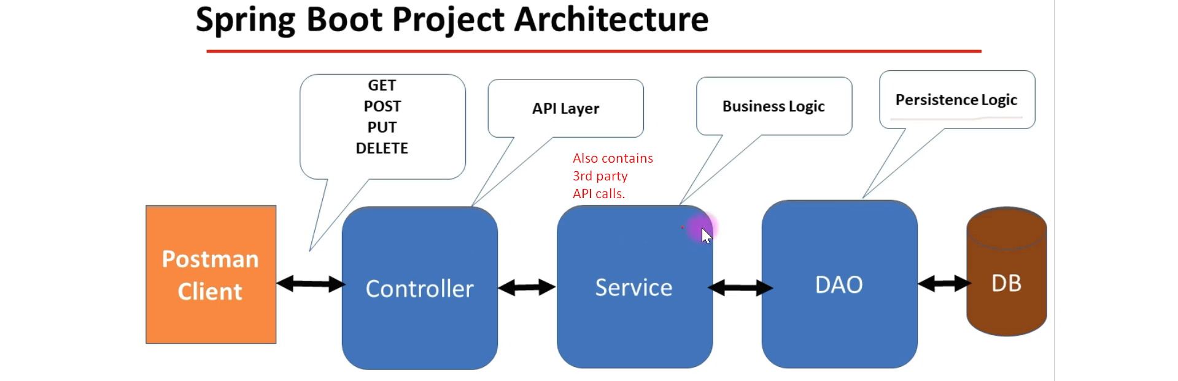
   1. Three Layers or 3-tired Architecture.
   2. **Controller**: also called API Layer as all the REST APIs is in Controller itself.
   3. **Service Layer**: Containing business logic and all calls to 3rd parties’ APIs.